Microsoft Office
PC or MAC
Mastering

..mdfkgjk jkjgkrgkkg kgfkdjgkdfgjlzdjgikj
Made Easy^{Tm}
^{jgjhj ytfyttytryr}
Versions 2010 through 97

Includes
Printable
Manuals!

DELUXE EDITION

Introductory through Advanced Material
1164+ Video Lessons
Convient
Complete
Easy to Use
Over 48 Hours of Professional Instructions
15 Printable Classroom Manuals
Practice Exercises
Keyboard Shortcuts
Bring our
classroom to
your
computer!

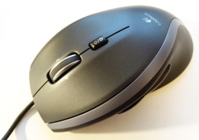
Learn. Explore. Discover.
Seven Complete Tutorials!
The Ultimate Collections!
- Access
- Excel

- Outlook
- PowerPoint
- Publisher
- Windows
- Word

